**Paint new sprite**

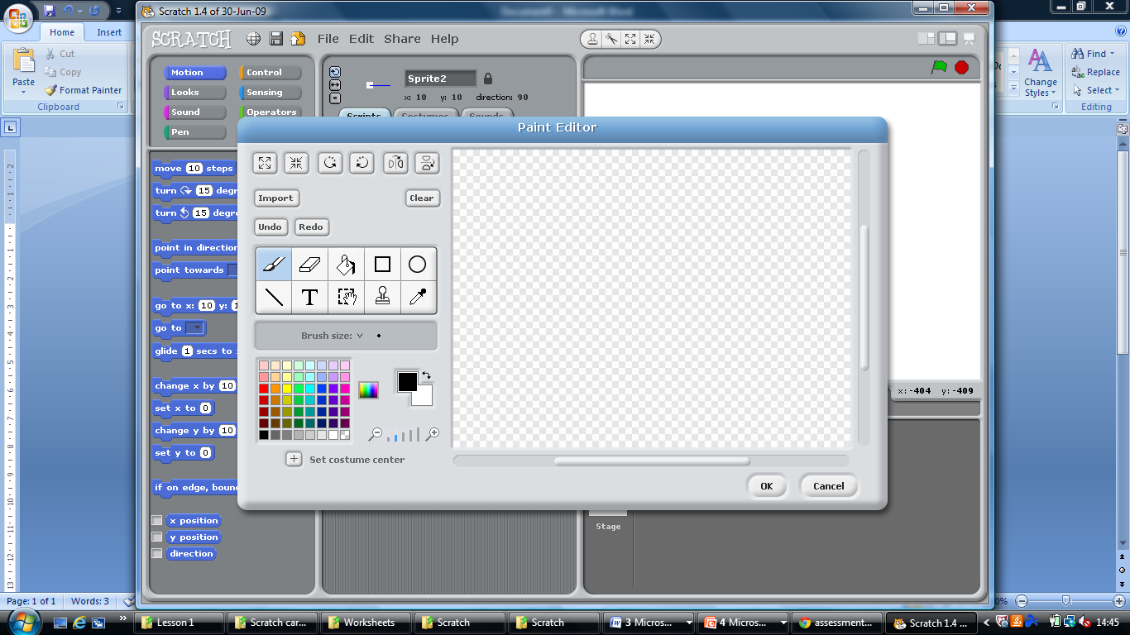

FLIP Horizontally

ROATATE clockwise

FLIP vertically

ROTATE Counter clockwise

GROW

SHRINK

Text tool

Select tool

Stamp tool

Eyedropper tool

Line tool

Eclipse tool

Rectangle tool

Fill

Eraser

Paint brush